Q1:

Protein Name: RBP4 retinol binding protein 4

Gene ID: 5950 https://www.ncbi.nlm.nih.gov/gene/5950

Species: Homo Sapiens (Humans)

Accession Number: NP_006735

Function: It’s expressed in the liver, a member of the lipocalin family and works as retinol carrier(vitamin A alcohol) in the blood. It delivers retinol from the liver stores to the peripheral tissues. A deficiency of vitamin A blocks secretion of the binding protein post translationally and results in defective delivery and supply to the epidermal cells.

Q2:

**Method**: TBLASTN (2.7.1) search in dog, cayote and wolf against ESTs

Database: expressed sequence tags(ESTs)

Organism: dog, coyote, wolf (taxid: 9608)

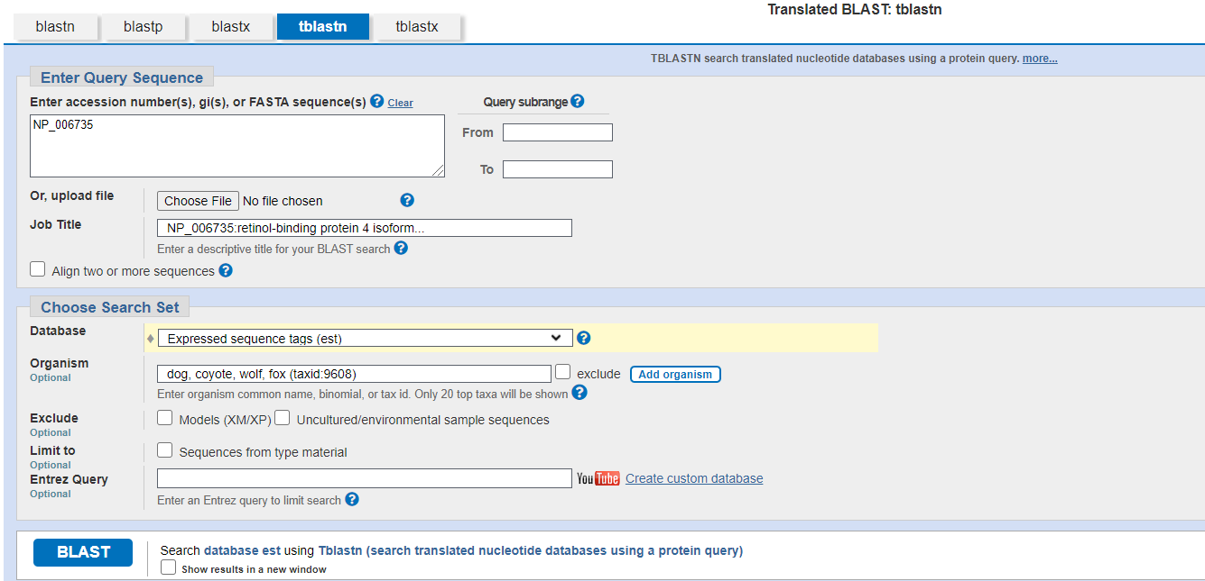

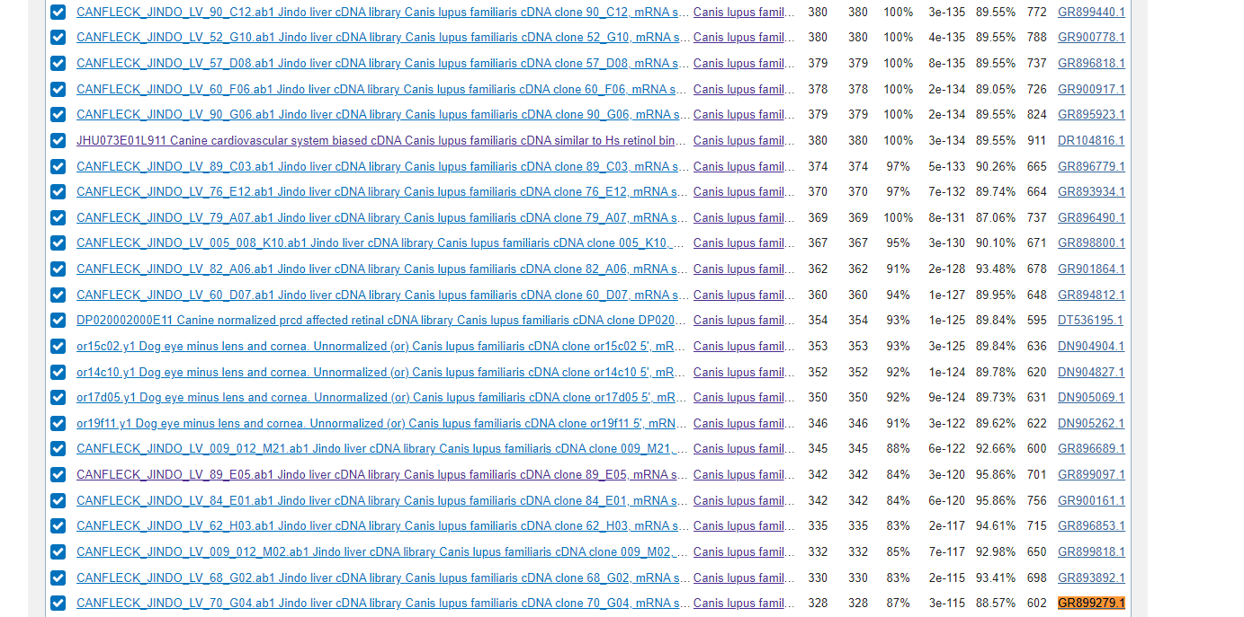

**The chosen match is accession GR899279.1, with 602 nucleotides in the sequence, and belongs to the Canis lupus familiaris species.**

**CANFLECK_JINDO_LV_70_G04.ab1 Jindo liver cDNA library Canis lupus familiaris cDNA clone 70_G04, mRNA sequence**

**Sequence ID:**[**GR899279.1**](https://www.ncbi.nlm.nih.gov/nucleotide/GR899279.1?report=genbank&log$=nuclalign&blast_rank=28&RID=PBZYFXS0016) **Length: 602 Number of Matches: 1**

Range 1: 76 to 600

|  |  |  |  |  |  |  |
| --- | --- | --- | --- | --- | --- | --- |
| **Alignment statistics for match #1** | | | | | | |
| Score | Expect | Method | Identities | Positives | Gaps | Frame |
| 328 bits(840) | 3e-115 | Compositional matrix adjust. | 162/175(93%) | 169/175(96%) | 0/175(0%) | +1 |

Query 1 MKWVWallllaalGSGRAERDCRVSSFRVKENFDKARFSGTWYAMAKKDPEGLFLQDNIV 60

M+WVWAL LLAALGS RAE DCRVS+F+VK+ FDKARF+GTWYAMAKKDPEGLFLQDNIV

Sbjct 76 MEWVWALELLAALGSARAESDCRVSNFQVKKTFDKARFAGTWYAMAKKDPEGLFLQDNIV 255

Query 61 AEFSVDETGQMSATAKGRVRLLNNWDVCADMVGTFTDTEDPAKFKMKYWGVASFLQKGND 120

AEFSVDE G+MSATAKGRVRLLNNWDVCADMVGTFTDTEDPAKFKMKYWGVASFLQKGND

Sbjct 256 AEFSVDENGRMSATAKGRVRLLNNWDVCADMVGTFTDTEDPAKFKMKYWGVASFLQKGND 435

Query 121 DHWIVDTDYDTYAVQYSCRLLNLDGTCADSYSFVFSRDPNGLPPEAQKIVRQRQE 175

DHWI+DTDYDTYAVQYSCRLLNLDGTCADSYSFVFSRDPNGLP EAQKIVRQRQE

Sbjct 436 DHWIIDTDYDTYAVQYSCRLLNLDGTCADSYSFVFSRDPNGLPLEAQKIVRQRQE 600

Q3: The sequence is :

>C. lupus familiaris liver protein(sequence taken from BLAST result)

MEWVWALELLAALGSARAESDCRVSNFQVKKTFDKARFAGTWYAMAKKDPEGLFLQDNIVAEFSVDENGRMSATAKGRVRLLNNWDVCADMVGTFTDTEDPAKFKMKYWGVASFLQKGNDDHWIIDTDYDTYAVQYSCRLLNLDGTCADSYSFVFSRDPNGLPLEAQKIVRQRQE

Name: Canis lupus familiaris Liver protein

Animalia, Chordata, Mammalia, Carnivora, Canidae, Canis, Lupus, familiaris

Q4:

**A BLAST-P search against NR database (see setup in first screen-shot below) yielded a**

**top hit result is to a protein from Canis lupus familiaris.**

**Since the percent identity is 98.9% less than 100%, it’s likely to be a novel protein.**

This protein seems to be a novel protein as it has 98.9% identity with the top hit.

The e-value is 3*10^(-125)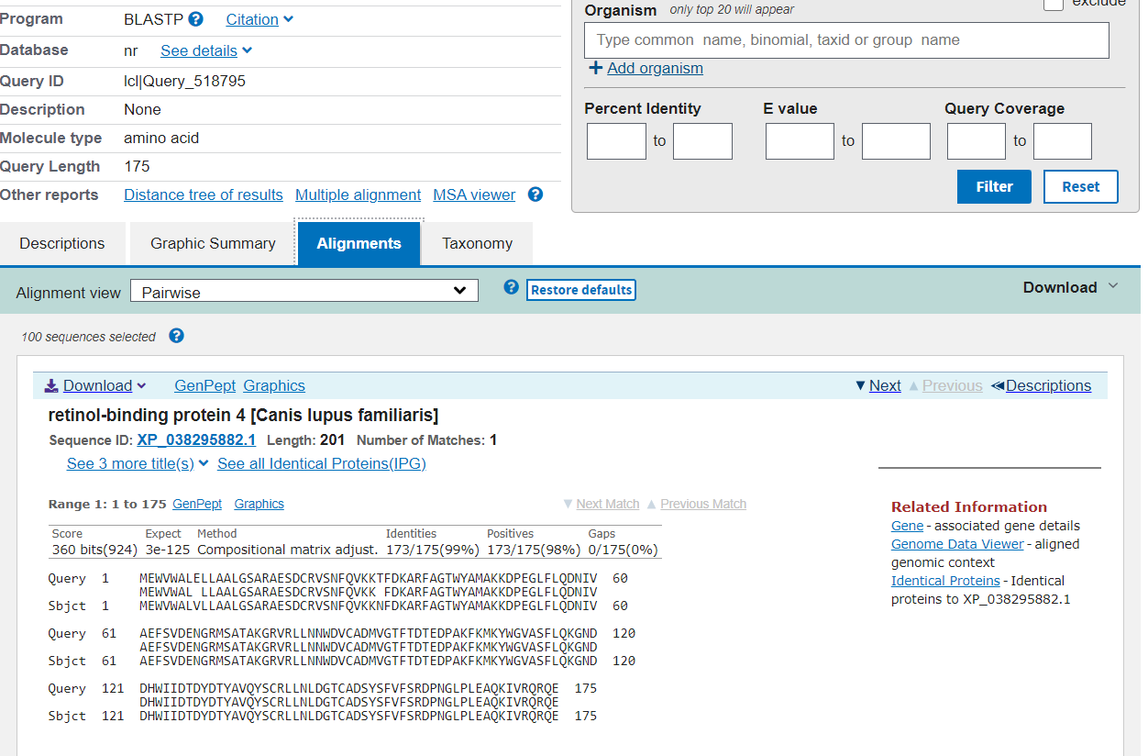

Fasta result:

https://www.ebi.ac.uk/Tools/services/web/toolresult.ebi?jobId=fasta-I20211104-184820-0908-48368064-p2m